DATE :
EXPERIMENT - 4
CREATE A SIMPLE CLOUD SOFTWARE APPLICATION FOR CAR BOOKING RESERVATION SYSTEM USING ANY CLOUD SERVICE PROVIDER TO DEMONSTRATE SAAS.
AIM: 28-02-26
To Create a simple cloud software application for Car Booking Reservation System using any Cloud Service Provider to demonstrate SaaS.
PROCEDURE:
step1: Go to zoho.com.
step 2: Log into the zoho.com.
step 3: Select one application step.
step4: Enter application name as Car Booking Reservation System. step 5: Created new application as Car Booking Reservation System. step 6: Select one form
step 7: The software has been created.
IMPLEMENTATION:
STEP1: GOTO ZOHO.COM
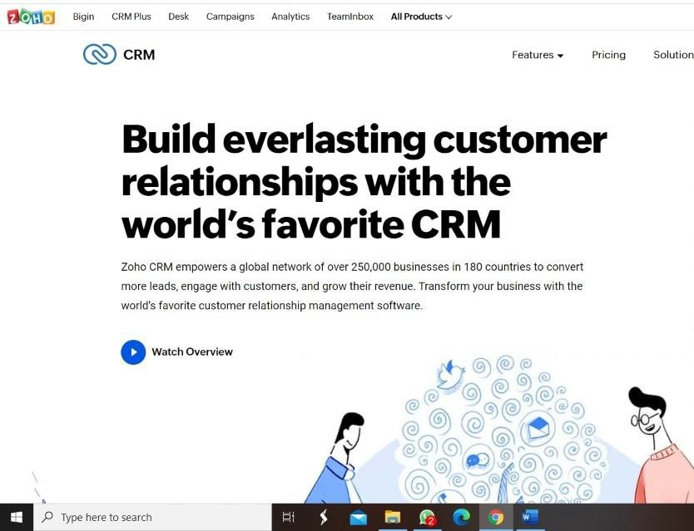

STEP 2: LOGINTOTHE ZOHO.COM

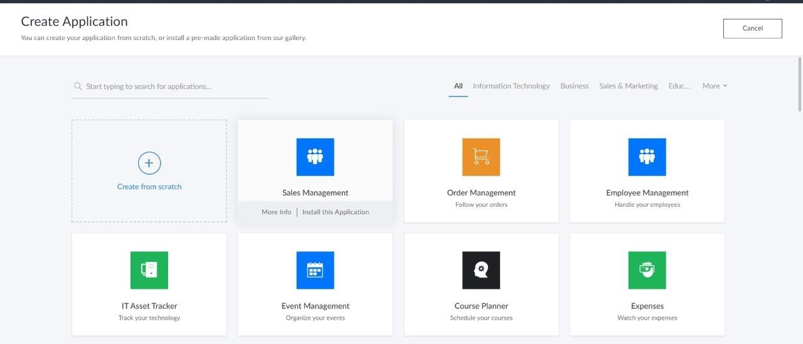
STEP 3: SELECT ONE APPLICATION
STEP 4: ENTER APPLICATION NAME
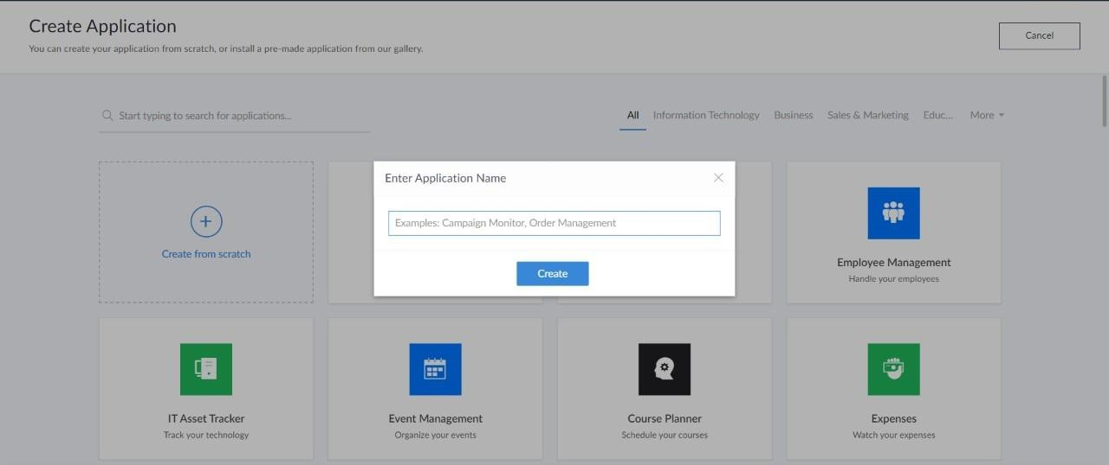

STEP 5: CREATED NEW APPLICATION
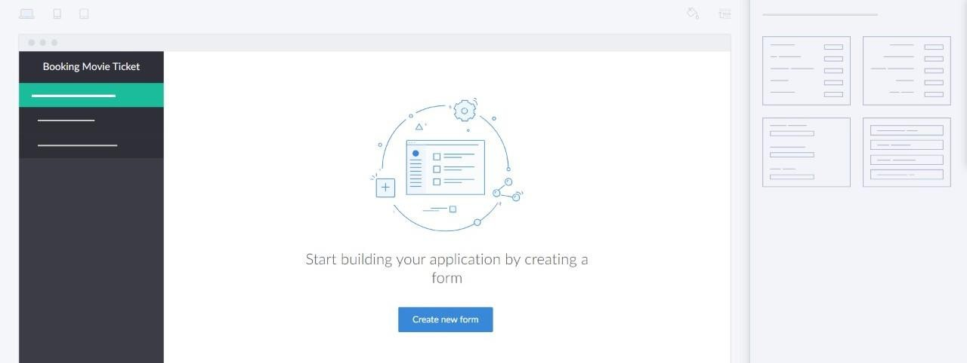
STEP 6: SELECT ONE FORM
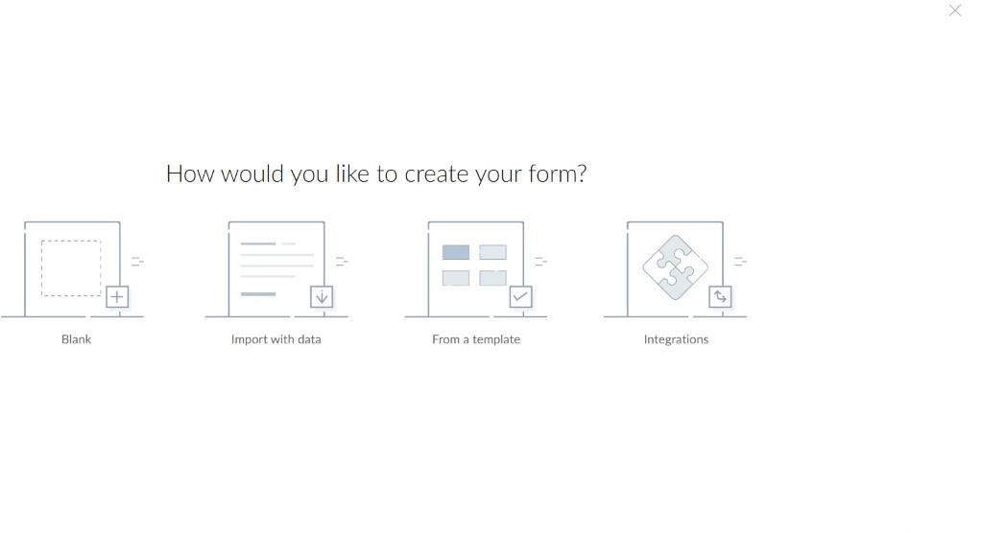
STEP 7: THE SOFTWARE HASE BEEN CREATED.
